**INTERNAL ASSESSMENT REPORT**

**Submitted to**

**Dr. L Sudershan Reddy**

**Professor of Quants**

|  |
| --- |
| **Course: Statistics for Managers**  **Course Code: 22MBACC103**  **Component No:   Assignment - 2**  **Assessment Method: Group presentation**  **Maximum marks: 10 marks**    **Topic:**  **Semester:     FIRST SEMESTER**  **Section: O**  **Batch:**  **Date of Submission:17/11/2022** |

|  |
| --- |
| **Group Name:  FINAL FOUR** |

|  |  |  |  |  |  |  |
| --- | --- | --- | --- | --- | --- | --- |
| **Sl. No.** | **Student Name (in Caps)** | **Regd. No.** | **Signature of the Student** | **Marks Awarded**  **(individual)** | **Marks Awarded**  **(Group)** | **Total**  **Secured Marks**  **(Max 10)** |
| **1** | **BHARATH S** | **CMSBS/16058** |  |  |  |  |
| **2** | **KOUSHIK S.U** | **CMSBS/18333** |  |  |  |
| **3** | **HAMSHIK U.R** | **CMSBS/14232** |  |  |  |
| **4** | **ROHIT KUMAR** | **CMSBS/17552** |  |  |  |

**TABLE OF CONTENT**

|  |  |  |
| --- | --- | --- |
| **SL** | **PARTICULARS** | **PAGE NO** |
| **1** | **ABSTRACT** |  |
| **2** | **INTRODUCTION** |  |
| **3** | **SALE OF ELECTRIC VEHICLE TREND IN INDIA:** |  |
| **4** | **SALE OF ELECTRIC VEHICLE TREND IN INDIA:** |  |
| **5** | **MARKET SHARE OF COMPANIES OF ELECTRICAL VECHICLE:** |  |
| **6** | **CONCLUSION** |  |

**ABSTRACT**

IT has long been recognized that EVS are four times more effective than gasoline or diesel automobiles, which put 80 per cent of their strength at energy. What shifts this equation is the arrival of EV models with this speed and execution of the car five or 10 minutes less to pay. It is also a major shift from traditional electric vehicles like petrol and diesel cars. The electric vehicle market is expected to grow by a staggering 20 per cent over the next decade. This change will be driven by the increasing number of new EV models being introduced in India. The Indian government has already started implementing policies to encourage EV adoption among its citizens. It is estimated that there will be an increase in the number of EV models available by 2020. The country's leading manufacturers are now offering EV charging stations, which have been installed in almost every major city. Increase in sales. The rise in sales of electric vehicles has been attributed to increased demand for them.

To realize its dream of e-mobility, the Ministry of Power launched the National e-mobility plan in 2013. The project provided the roadmap for faster adoption of Electric Vehicles and their manufacturing in the country. It was designed to enhance national fuel security and provide eco-friendly transportation at affordable rates.

**INTRODUCTION**

The automotive industry in India has seen a rise in Electric Vehicles (EVs) in the past few years. According to a recent study, the Electric Vehicle market is expected to be worth INR 475 billion by 2025.The NITI Aayog is also optimistic about the future of the EV market in India. It estimates that 80% of two and three-wheelers, 40% of buses, and 30 to 70% of cars running on Indian roads will be electric by 2030. Currently, two-wheelers occupy the largest share of the EV market.

                    Indian Scenario is different as the current market share of EV/PHEV is around 0.1%. At present almost all vehicles rely on fossil fuel-based transportation. This pollutes the atmosphere by the emission of greenhouse gasses & causes global warming. The Indian transportation sector is growing very fast. Unlike other countries the vehicle to people ratio in India is very high, however, the population is more and emission is high. India stands third with the CO2 emission of 1.726 billion Mt.. Hence there is an urgent need to focus towards EV technology which has capability towards zero emission for sustainable transportation. In addition, due to urbanization and decentralization of the city area, a rapid increase in personal vehicles has also been observed.The transportation sector is expected to grow about tenfold over the next four decades, driven by increasing uptake as incomes rise which is a challenge in aspects of traffic, road infrastructure etc. Looking into the growth, the current level of pollution and depletion of fossil fuel, there is a strong need to shift from conventional IC engine vehicles towards the electrified vehicle. At the moment demand for EV in India is quite small. By industry estimates, less than 5% of the passenger car market in India would comprise electric cars over the next 5–7 years.

**Why Does the Future Look Optimistic for the EV Industry?**

With tech giants like Tesla set to launch their Electric Vehicle models in India, the adoption of EVs is expected to increase. Additionally, the government is also working to create a suitable environment for a strong e-mobility ecosystem in India.

**EV Adoption Campaigns**

Metro cities like Delhi and Kolkata are leading the way for e-mobility in Indian cities. The cities encourage the use of e-rickshaws to save operation and economic costs. There are reportedly over 1 lakh e-rickshaws in Delhi, and Kolkata is slowly following suit. This has led to an increase in the purchase of EVs for personal use as well.

The Delhi government also introduced the 'Switch Delhi' campaign to promote the adoption of EVs. The campaign received overwhelming support from the youth of the city. The city's transportation minister announced an increase in the registration of electric two-wheelers since the campaign's launch.

To realize its dream of e-mobility, the Ministry of Power launched the National e-mobility plan in 2013. The project provided the roadmap for faster adoption of Electric Vehicles and their manufacturing in the country. It was designed to enhance national fuel security and provide eco-friendly transportation at affordable rates.

**BENEFITS OF EV VEHICLE:**

* LOWER RUNNING COSTS:

       The running cost of electrical is lesser compared to petrol or diesel vehicle. Its can me still less by using renewable resource.

* LOW MAINTENANCE COST:

     Electric vehicle have very low maintenance because it is simple to service compared to diesel or petrol they have internal parts for the combustion for moving of vehicle.

* ZERO TAILPIPE EMISSIONS:

     Electrical vehicle doesn’t produce zero tailpipe emission . we can reduce environmental impact by using solar energy for charging the vehicle.

* TAX AND FINANCIAL BENEFITS:

   Registration and road tax is less compared to petrol or diesel vehicle and there are certain benefit giving by government.

* NO NOISE POLLUTION:

    These are silent functioning because they move on electrical motor and they have been installed with false sounds for safety of pedestrians.

**SALE OF ELECTRIC VEHICLE TREND IN INDIA:**

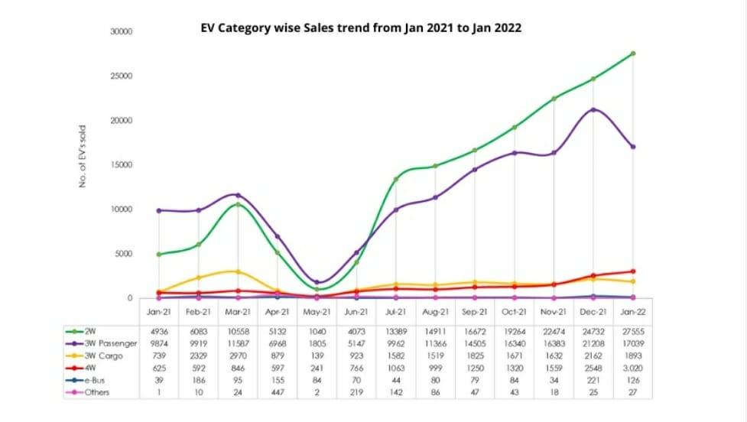  
  
 INTERPRETATION:

In the above table tell about the sales of electrical vehicle of different segments, 2w has been increasing , 3w passenger has been falling, 4w has been slightly increasing at the last, Other segment left r almost constant

**SALE OF EV IN INDIA 2021 (STATE-WISE):**

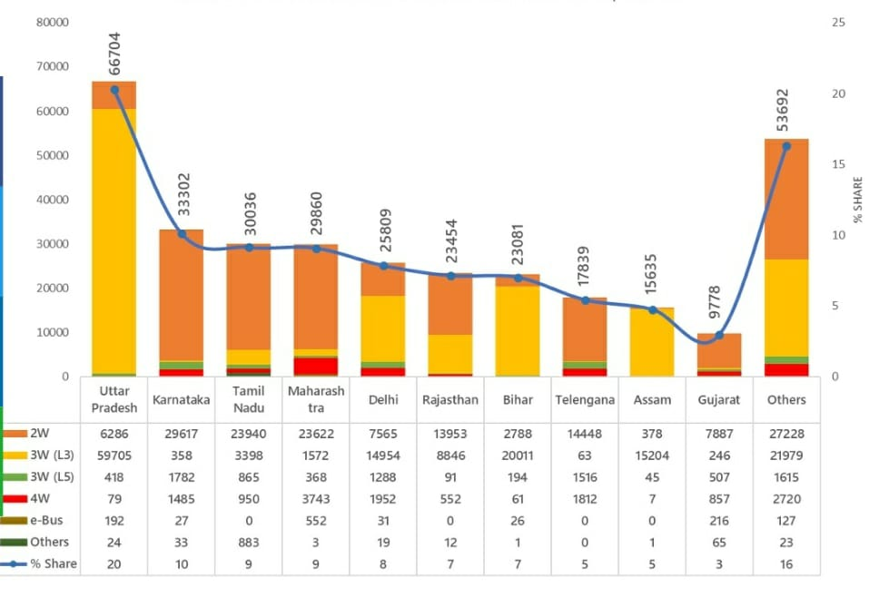

INTERPRETATION**:**

The above graph tell the total sale of vehicles of different states and uttarpradesh stands first on sale of ev and the later come the following

X axis are the number of units sold in 1000

Yaxis consists of different states

**MARKET SHARE OF COMPANIES OF ELECTRICAL VECHICLE:**

                       Hero Electric, Okinawa and Ather Energy controls the electric two-wheeler market in India with a combined market share of 64%. Hero Electric has a market share of 36% followed by Okinawa with 21%. Ather Energy with an 11.1% market share is slowly gaining market share, as the company is currently expanding its distribution network across India. In the passenger vehicle segment, Tata Motors enjoys a commanding position in electric vehicle space with a market share of 71%, led by their two key models, Nexon and Tigor EV. MG Motors India enjoys the second position and offers the longest-range EV (MG EZS provides 439 KM range on a single charge). Other Indian manufacturers have announced their models and is expected to be launched in the future.

**TWOWHEELER MARKET      FOURWHEELER MARKET**

**SHARES                                                  SHARES**

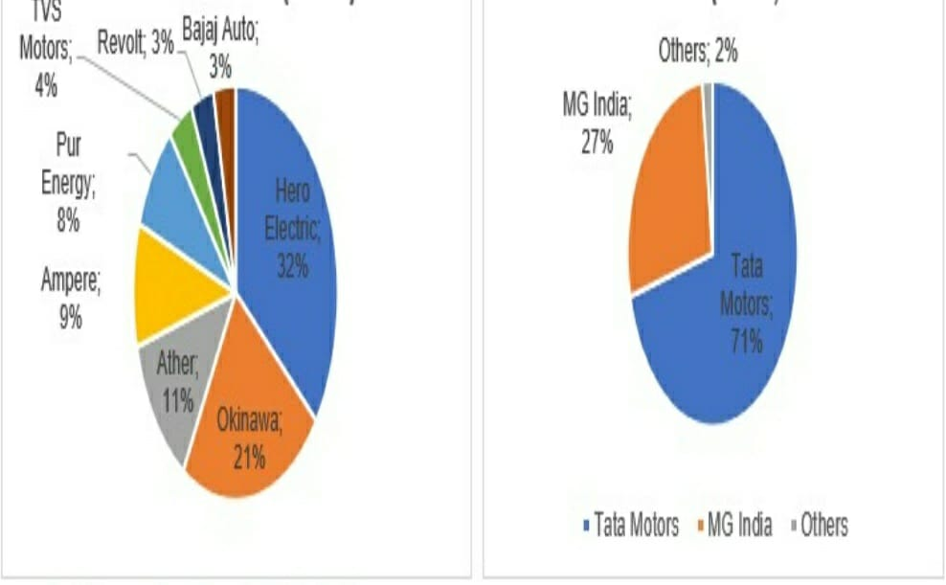

INTERPRETATION:

THE ABOVE PIE CHART OF TWO WHEELER WHERE HERO ELECTRIC HAS THE TOTAL AMOUNT OF LARGE SALE

THE ABOVE PIE CHART OF FOUR WHEELER WHERE TATA ELECTRIC HAS THE TOTAL AMOUNT OF LARGE SALES

**Conclusion**

The Indian EV Industry is slowly gathering momentum, supported by government initiatives and rise in crude oil prices, as people look for alternative sources to reduce their monthly bills. However, a mass shift from internal combustion engine (ICE) vehicles to EVs requires expansion of infrastructure facilities, including charging stations, and vehicles that could provide a higher range (KM range with a single charge). Several initiatives taken by the government to support the manufacturing and adoption of electric vehicles in the country should help in achieving the target of a 100% EV adoption by 2030.